
YEAR 12 CHEMISTRY – 3BCHE

TEST 4

Redox and Electrochemical Cells

/ 40

Recommended time: 1 hour

Name: _____________________________________________________

Teacher: _____________________________________________________

MULTIPLE CHOICE QUESTION BOOKLET

This test is in three parts.

Part 1: is a multiple choice style test of fifteen (15) questions. Each question is of equal value and marks are not deducted if an answer is incorrect, SO ATTEMPT ALL QUESTIONS. Mark your choice of the most appropriate answer on the attached multiple choice answer sheet. In the event that you wish to change your response, erase the incorrect answer and then mark the new choice in the space provided.

Part 2: is made up of 2 short and/or extended answer questions and should be answered in the spaces provided in the ANSWER BOOKLET. The marks allocated for each question are shown at the end of each question.

Part 3: is made up of 1 calculation type question worth a total of 12 marks. The marks for each part of the question are shown. Write your answers in the spaces provided using a blue or black ink pen.

PLEASE DO NOT TURN THE PAGE UNTIL INSTRUCTED TO DO SO

PART 1 : Multiple Choice

Mark your answers on the sheet provided. (15 marks)

1. Which one of the following reactions does not represent an oxidation-reduction reaction?

- 2MnO₄⁻(aq)+2H₂O()+ 3C₂O₄²⁻(aq) → 2MnO₂(aq) + 6CO₃²⁻(aq) + 4H⁺(aq)
- Cr₂O₇²⁻(aq) + H₂O() → 2CrO₄²⁻(aq) + 2H⁺(aq)
- 2Br₂(aq) + N₂H₅⁺(aq) → N₂(g) + 5H⁺(aq) + 4Br⁻(aq)
- 6I⁻(aq) + 14H⁺(aq) + Cr₂O₇²⁻(aq) → 3I₂(aq) + 7H₂O() + 2Cr³⁺(aq)

The next TWO questions refer to the following oxidation-reduction equation:

2 MnO₄¯ _{(aq)} + 5 H₂S_{(aq)} + 6 H⁺ _{(aq)}  2 Mn²⁺_{(aq)} + 5 S_{(s)} + 8 H₂O_{(l)}

2. The substance which has been oxidised in the above reaction is

    - MnO₄¯
    - H⁺
    - H₂S
    - S_{(s)}

3. The oxidation number of sulfur in this reaction has changed from

- –2 to 0
- +2 to 0
- 0 to –2
- 0 to +2

4. A substance which gives up electrons readily is

  - known as an oxidising agent.

  - easily reduced.

  - a good reducing agent

  - able to readily accept protons.

5. Which one of the following reactions involves the transfer of electrons?

  - CaCO_{3(s)} 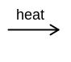 CaO_{(s)} + CO_{2(q)}
  - Ba²⁺_{(aq)} + SO₄²⁻ _{(aq)} 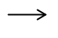 BaSO_{4(s)}
  - NaOH_{(aq)} + HCl_{(aq)} NaCl_{(aq)} + H₂O_{(l)}
  - Cu_{(s)} + 2Ag⁺ Cu²⁺_{(aq)} + 2Ag_{(s)}

6. In the reaction of concentrated sulfuric acid on copper,

Cu + 2H₂SO₄ CuSO₄ + SO₂ + 2H₂O

Which of the following statements applies?

  - Sulphur in H₂SO₄ is oxidised;
  - Hydrogen in H₂SO₄ is oxidised;
  - Copper is the reductant;
  - Copper is the oxidant.

7. Which of the following cells would you expect to produce the highest e.m.f.? (Assume all electrolytes to be one molL⁻¹ aqueous solutions.)

  - Mg/Mg²⁺ // Zn²⁺/Zn
  - Mg/Mg²⁺ // Fe²⁺/Fe
  - Mg/Mg²⁺ // Ni²⁺/Ni
  - Mg/Mg²⁺ // Cu²⁺/Cu

8. In the cell Zn/Zn²⁺ // Ag⁺/Ag, the species reduced is:

  - Zn
  - Zn²⁺
  - Ag⁺
  - Ag

Note: The next three (3) questions refer to the diagram and the equations below.
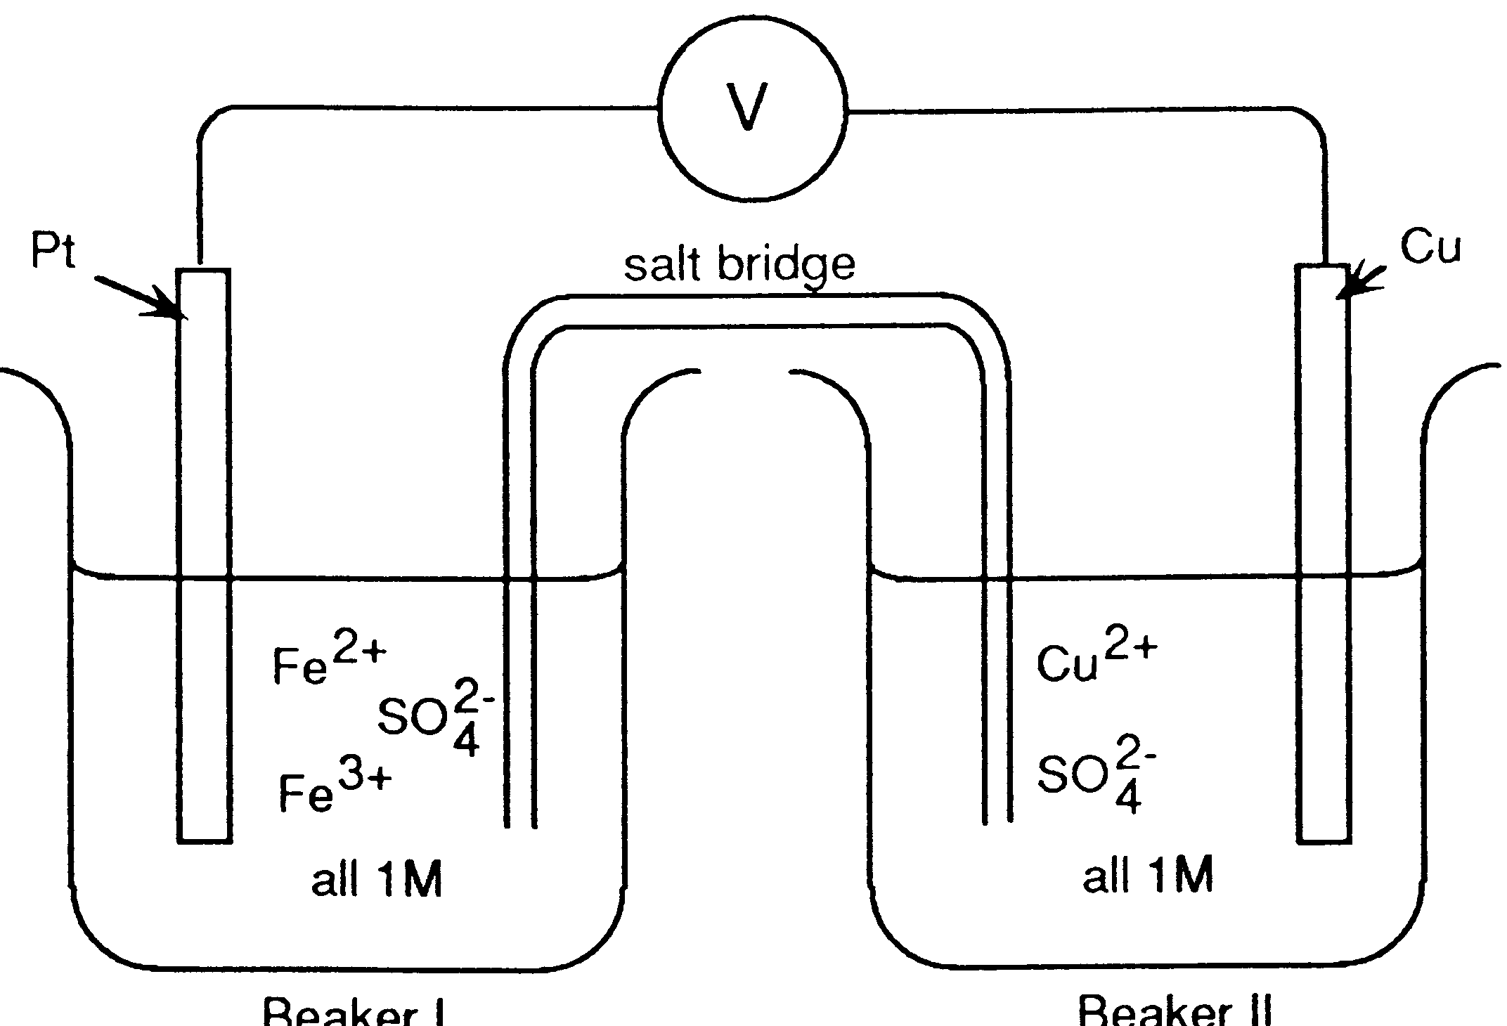
BEAKER I
BEAKER II

Note:
M = molL⁻¹

Fe³⁺ + e‾ Fe²⁺ E⁰ = 0.77 V
Cu²⁺ + 2e‾ Cu E⁰ = 0.34 V
Fe²⁺ + 2e‾ Fe E⁰ = -0.44 V

9. If the salt bridge contained KNO₃ solution, the:
  - K⁺ ions move from beaker I and are replaced by Cu²⁺ ions.
  - NO₃‾ ions migrate into beaker I and are replaced by SO₄²‾ ions from
beaker II.
  - K⁺ ions move into beaker I and NO₃‾ ions move into beaker II.
  - K⁺ ions move into beaker II and NO₃‾ ions move into beaker I.

10. In the above cell the electrons will:
  - Flow in the wire from Cu to Pt.
  - Flow in the wire from Pt to Cu.
  - Not flow through the wire.
  - Flow through the salt bridge from Cu²⁺ to Fe²⁺

11. If the platinum electrode is replaced by an iron electrode, then:
  - The electrons will not flow through the wire
  - The electrons will flow in the wire from copper to iron.
  - The electrons will flow in the wire from iron to copper.
  - Electrons will flow through the salt bridge from beaker II to beaker I

12. The reason that the half-reaction
2H⁺_{(aq)} + 2e‾ H_{2(g)} has an Eº value of 0.000 V is that:
  - It is most often used by scientists.

  - This is an arbitrarily set reference.

  - The value is known accurately.

  - Hydrogen is not a liquid at 25⁰C.

13. The following half-cell reaction equations have been taken from the Eº table:

Zn²⁺ + 2e‾ Zn E⁰ = -0.76 volt
Cd²⁺_{(aq)} + 2e‾ Cd E⁰ = -0.40 volt
The two metal electrodes are connected through a voltmeter and the solutions are connected by a salt bridge. The reading on the voltmeter would be:

  - 1.16 V
  - 0.76 V
  - 0.40 V
  - 0.36 V

14. Select the compound in which chlorine is assigned the oxidation number +5.

  - HCIO
  - HCIO₂
  - HCIO₃
  - HCIO₄

15. The purpose of a salt bridge in an electrochemical cell is to:

a. Separate the two half-cells physically, but provide a complete circuit
for the movement of electrons:
b. Separate the two half-cells physically, but allow the passage of ions.
c. Permit a migration of positive ions to the reducer half-cell only.
d. Permit a migration of positive ions to the oxidiser half-cell only.

END PART 1

Belmont City College

Year 12 Chemistry Test 4

Multiple-Choice and Short Answer Booklet Total 40 marks

Name: _____________________________

Teacher: _____________________________

For each question, shade the box to indicate your answer.
Use only a blue or black pen to shade the boxes.

For example, if b is your answer: a  b  c  d 

If you make a mistake, place a cross through that square then shade your answer.
Do not erase or use correction fluid.

For example, if b is a mistake and d is your correct answer: a  b  c  d 

If you then want to use your first answer b, cross out d and then circle b.

a  b  c  d 
Marks will not be deducted for incorrect answers.
No marks will be given if more than one answer is completed for any question.

Questions 1-15

1 | a  b  c  d  |  | 9 | a  b  c  d 
2 | a  b  c  d  |  | 10 | a  b  c  d 
3 | a  b  c  d  |  | 11 | a  b  c  d 
4 | a  b  c  d  |  | 12 | a  b  c  d 
5 | a  b  c  d  |  | 13 | a  b  c  d 
6 | a  b  c  d  |  | 14 | a  b  c  d 
7 | a  b  c  d  |  | 15 | a  b  c  d 
8 | a  b  c  d 
(15 marks)

PART 2 : SHORT ANSWER (13 Marks)

Answer questions in the space provided. Note that NOT all questions carry equal marks.

1. This question refers to the diagram and information below. Use labels to show on the diagram, the
(a) anode;
(b) cathode;
(c) direction of the electron flow, and
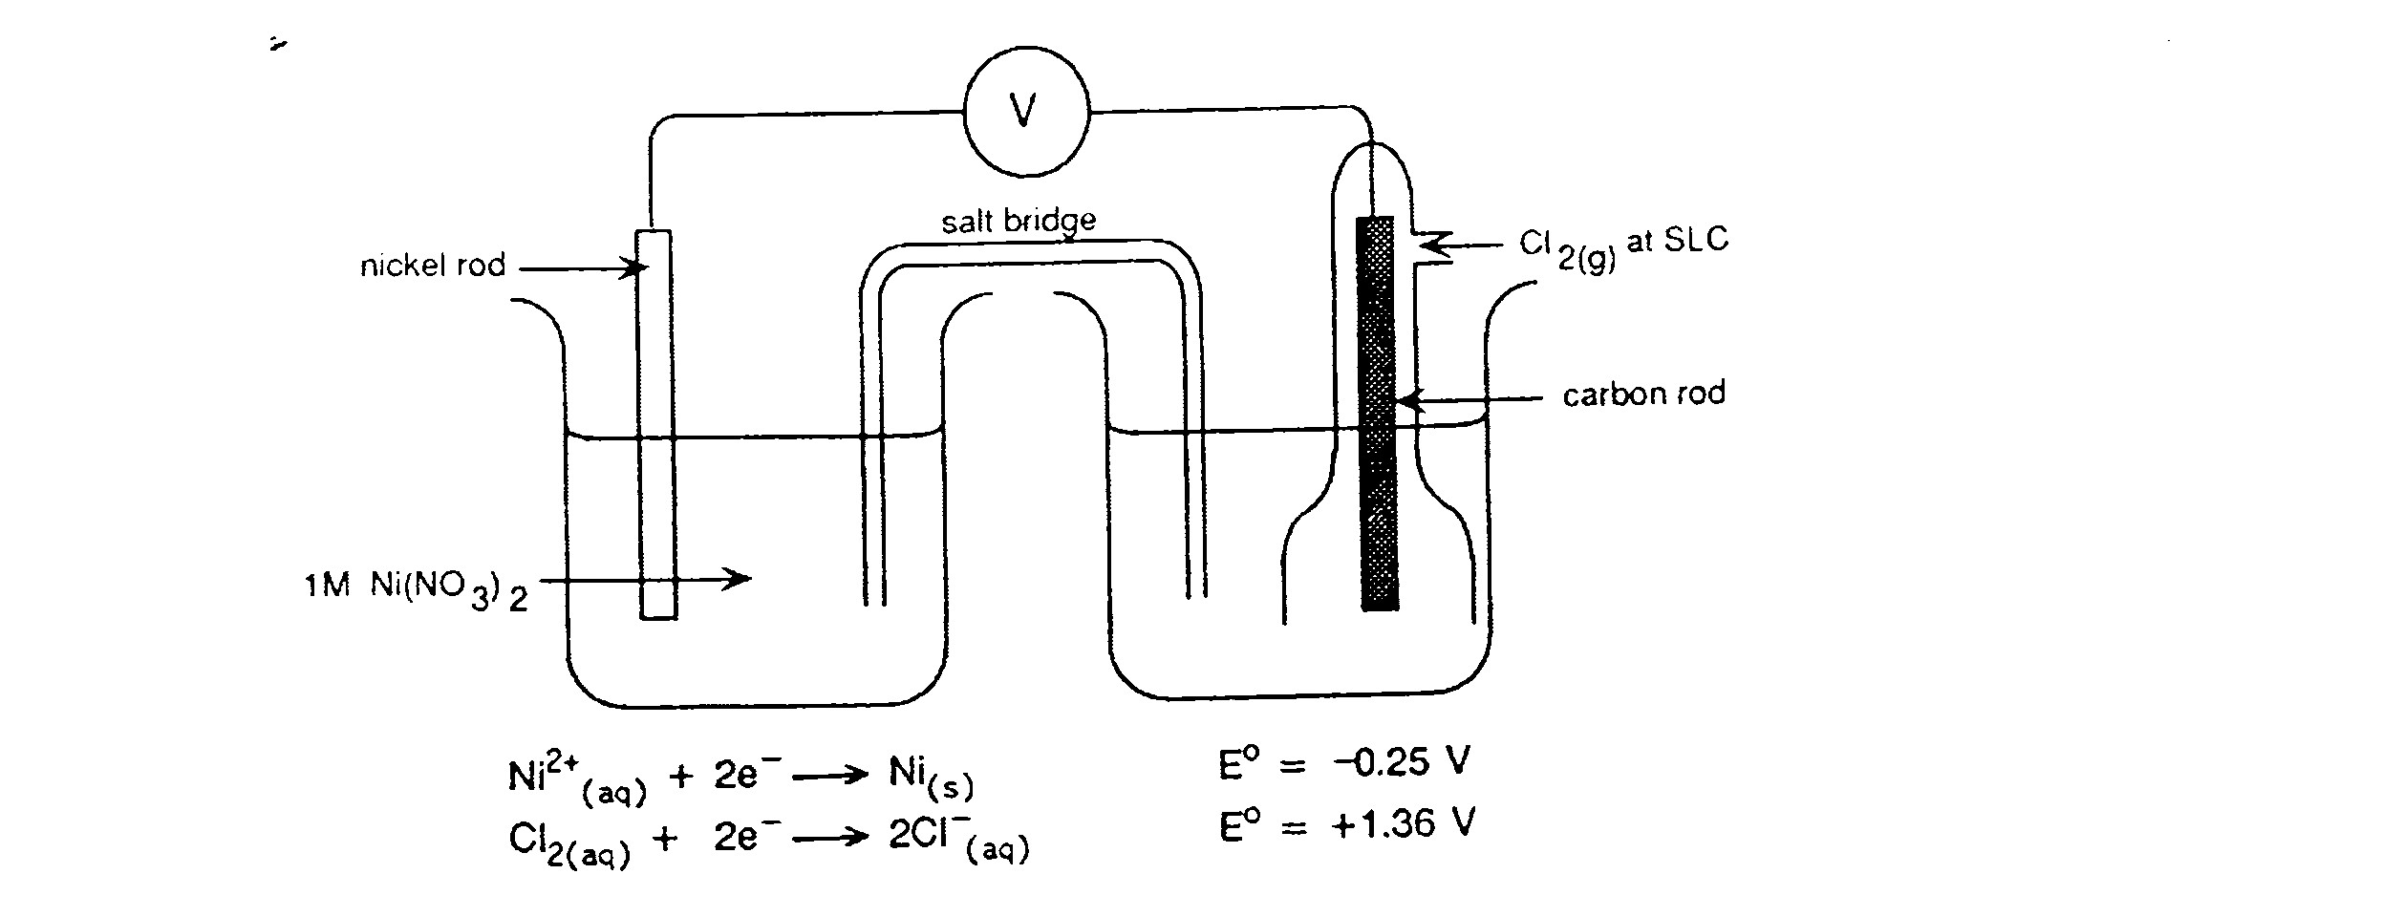
(d) direction of migration of ions in the salt bridge.
(4 marks)

Write the overall chemical equation for this electrochemical cell:

__________________________________________________________________
(1 mark)

2. A student was given freshly prepared solutions of iron (II) sulfate, sodium bromide, bromine water and acidified potassium permanganate. She carried out the tests shown in (a), (b) and (c) below. For each test, record any observed colour changes she may have seen, then write a net ionic equation to account for the observation.

(a) Small amounts of the iron (II) sulfate solution and bromine water were mixed and shaken.

Observation: _______

Equation:

(b) Small amounts of the iron (II) sulfate solution and potassium permanganate solutions were mixed and shaken.

Observation:

Equation:

(c) Small amounts of potassium permanganate solution and sodium bromide were mixed and shaken.

Observation:

Equation:

(d) From these results, state below, which of the four solutions contained:

(i) the most powerful oxidant

(ii) the most powerful reductant
(8 marks)


Look, if it was electric, could I do this?
PART 3: CALCULATION (12 marks)

Dichromate ion (Cr₂O₇²⁻) may be used in a titration to analyse hydrogen peroxide solutions.

(a) from your table of Standard Reduction Potentials, obtain

(i) the half equation for the reduction of dichromate ion (in acid conditions) to give chromium(III) ion, and

(ii) the half-equation for the oxidation of hydrogen peroxide (in acid conditions) to give oxygen.

(iii) Use these half-equations to construct the redox equation for the reaction that occurs when potassium dichromate solution is added to a solution containing hydrogen peroxide and sulfuric acid. (4 marks)

(b) Hairdressers use hydrogen peroxide to bleach hair. An analyst uses a pipette to transfer 20.00mL of commercial hairdressers’ hydrogen peroxide to a 250.0mL volumetric flask, and she makes the volume up to the mark with distilled water. She places 20.00mL portions of this solution in a titration vessel , adds 5.00mL of 2.00 mol L⁻¹ sulfuric acid, and titrates the mixture with 0.02056 mol L ⁻¹ potassium dichromate. She records the following titration figures:

Final reading (ml) | 29.5 | 29.53 | 29.35 | 28.74 | 28.62
Initial reading (ml) | 0.11 | 1.55 | 0.41 | 0.81 | 0.66

Calculate the appropriate value for the volume of potassium dichromate solution required for titration (2 marks)

(c) Calculate the concentration, in mol L⁻¹, of the original commercial hairdressers’ hydrogen peroxide. (6 marks)

END OF TEST Total: 40 Marks

